WANGARI MAATHAI

Chapter 1
FOOD
Berries: bayas
Nuts: nueces, tb puede significar cojones
Maize: maíz
Beans: frijoles
Wheat: trigo
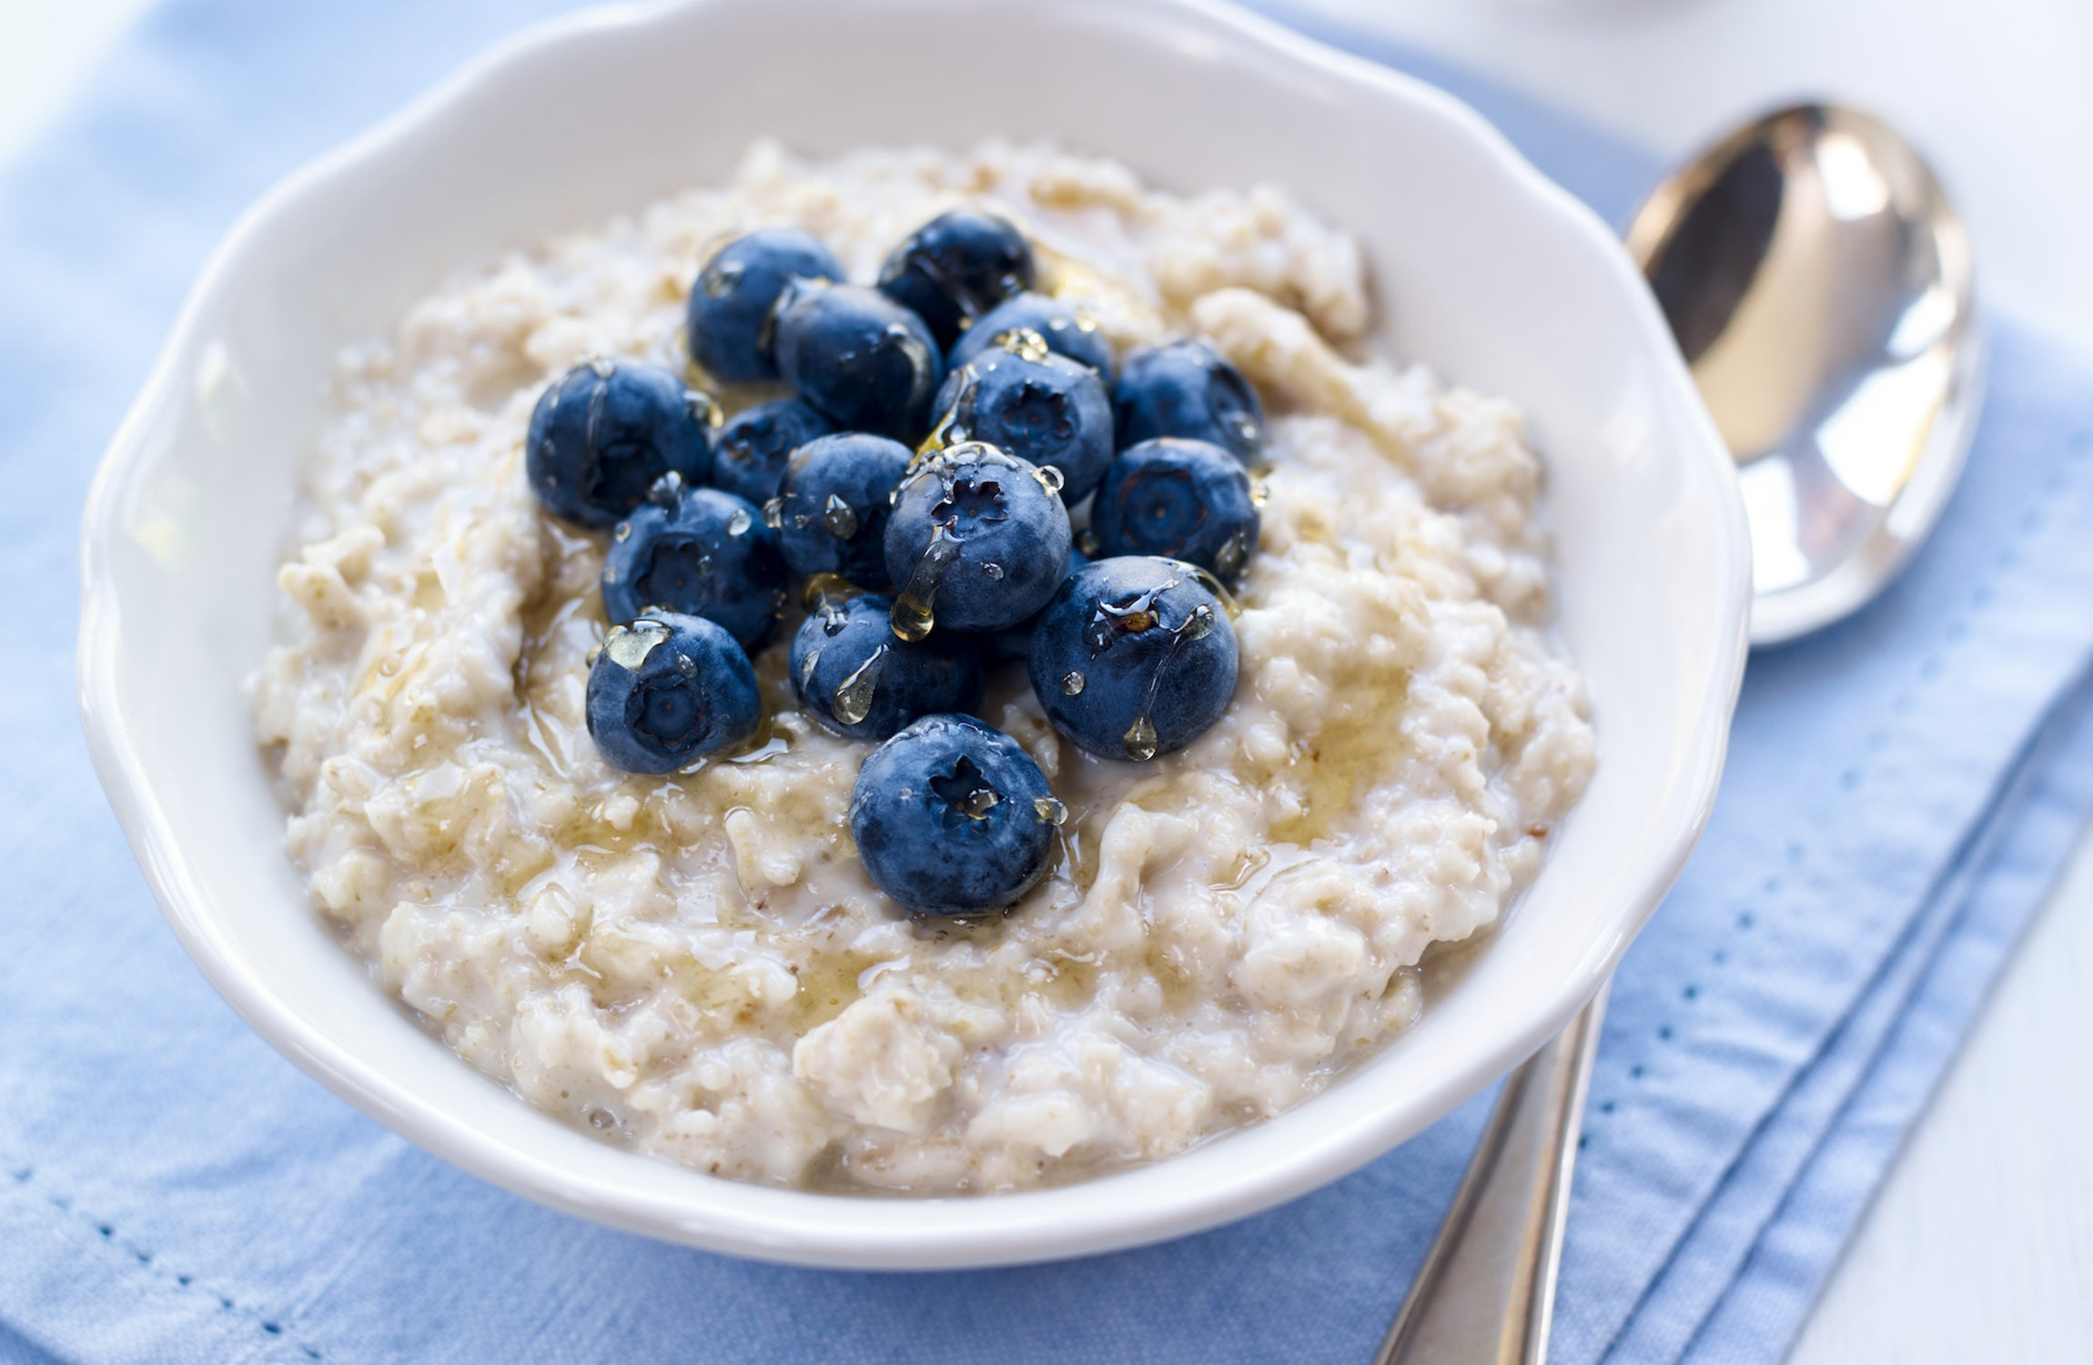
A bunch of bananas: un manojo de bananas
A ripe banana: una banana madura
Sweet potatoes: batatas
Sugarcane: caña de azúcar
Skimmed milk: leche desnatada
Millet: mijo (cereal) Porridge
Porridge: gachas de avena. A dish consisting of oatmeal
or antoher meal or cereal boiled in water or milk.

ANIMALS
Cattle: vacas
Goats: cabras
Sheep: ovejas or sheep: oveja
He-goat: chivo
Rhinos, lions, hipos, flamingoes

-1-
VEGETATION
Mud: barro
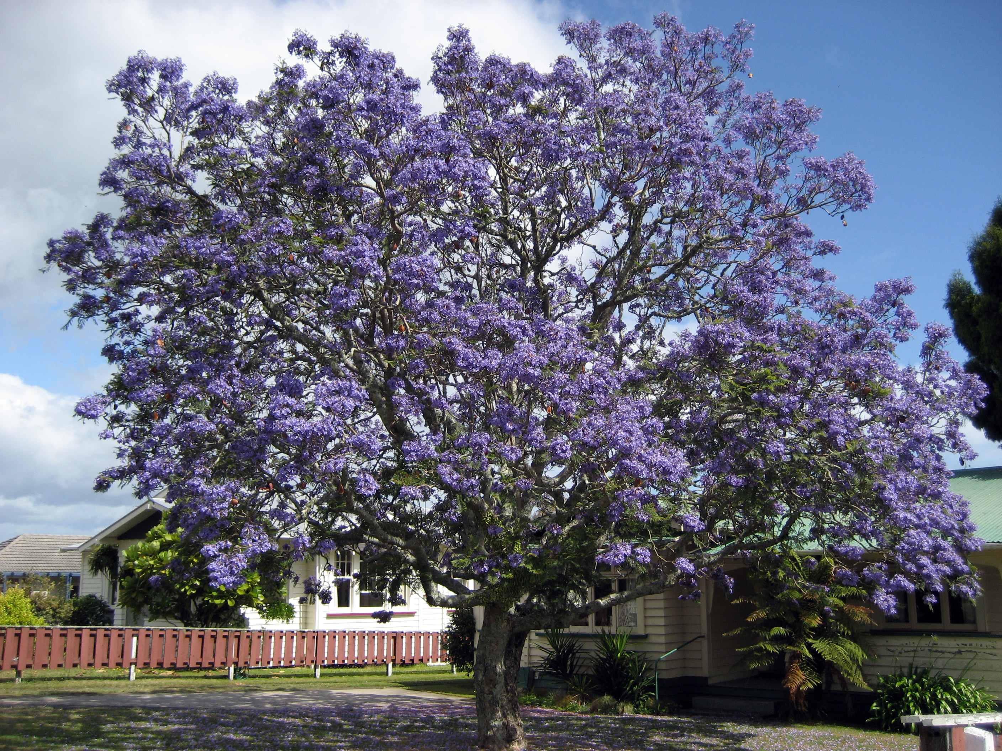
Lush: vegetation growing luxuriantly
Shrubs: arbustos
Creepers: enredaderas
Ferns: helechos
Moist: húmedo. Moist soil: tierra húmeda
Harvest: cosecha
Fig tree: higuera Jacaranda
Loggin: tala
Hunting wildlife: caza Silvestre
Ladscape: paisaje
Ridges: crestas (mountain)
Foothills: pies de la colina. Conjunto de montañas laterales, cerca de una población.
Soil: tierra
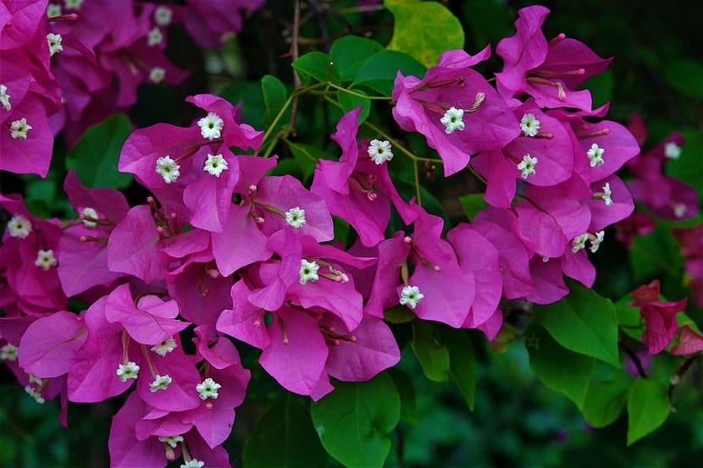
Crops: cultivos
Pine and aucalyptus: pino y eucaliptos
Branches: ramas
Jacarandas: a tree with purple flowers
Bougainvillea: shurb or creeper
Plows: arados
Harvesting: cosecha Bougainvillea
Tilled the soil: labró el suelo
Plucked weeds: malezas arrancadas

-2-
LINKERS
Nevertheless: however
At times: sometimes

ECONOMY
Trade: comercio
Yield /yilt/: rendimiento, producción
Seized: apoderada/do
Revenue: ingresos, earnings
Income tax: impuesto sobre la renta
Squatter: colono usurpador

WHATEVER
Gathered: reunido
Prophecy: profecía
Craftsmanship: artesanía
Died away: extinguido
Dwell: habitar
Hallowed: santificado
Broom: escoba
Slope: pendiente, inclinación
Lowlands: tierras bajas
Fat: grasa
Reluctant: reacia/o
Battlefield: campo de batalla
Fate: destino
-3-
Wiped: borrado
Shaped: dio forma
Unwavering: inquebrantable, wavering: titubeando
Warrents: órdenes
Peasant: campesina
Schism: cisma—division que se produce en una organización o de un movimiento cultural, cuando algunos individuos que forman parte de ella, la abandonan porque no están de acuerdo con la ideología.

-4-
Useful Language
They were to settle: deberían establecerse
I would have swallowed: habría tragado
Moonson rains: lluvias monzónicas
My parents were athoni, they dressed like Europeans as did I. (Inversion)
Died away: extinguido/da
Rather in heaven: más bien en el cielo
The goat was fattened, slaughtered and eaten: la cabra fue engordada, sacrificada y comida
I was shielded from all aspects of the death: fui protegida de todos los aspectos de la muerte
Dusk fell: cayó el anochecer dusk: oscuridad
Get the hell out of here: que te quites de aquí.
She would probably say with a chuckle: risita
Millions of flamingoes: millones de flamencos. (Millions in plural)
He was wiped from the face of the earth: desapareció de la faz de la tierra
She was sturdy: ella era fuerte, robusta
Sh never shouting or scolding: nunca grita o regaña
Sense of duty: sentido del deber
To pay a marriage dowry: property or money brought by a bride to her husband on their marriage.
Especially for kikuyus, many of whom had been forcibly displaced
My mother gave birth to my two younger sisters
QUESTIONS
Was it my responsibility to move, or my mother`s to tell met to?
How can anybody have so many dresses? (énfasis)

Ana, Pilar, Rocío y Melania . C1.1

